Name: Shailja Kant Tiwari

Course:B.Sc(H)Physics,Sem5

Roll No.-081

Source Code:

clear;clf;

a=input("Enter a:")

function **dx**=f(**r**, **x**, **E**)

e=3.795; m=0.511*10^6; h=1973;

V=-(e^2)*exp(-**r**/a)/**r**

**dx**(1)=**x**(2)

**dx**(2)=((2*m)/(h*h))*(V-**E**)\***x**(1)

endfunction

E1=input("Enter guess 1 for energy(eV):");

E2=input("Enter guess 2 for energy(eV):");

tol=abs(E1-E2)

while tol>0.000001

tol=abs(E1-E2)

r=0.01:0.01:8

u1=ode([0.01;1],0.01,r,list(f,E1));

u2=ode([0.01;1],0.01,r,list(f,E2));

E3=(E1+E2)/2

u3=ode([0.01;1],0.01,r,list(f,E3));

if(u1(1,800)*u3(1,800))<0 then

E2=E3

else

E1=E3

end

end

disp(E3,"The energy eigen value (eV) for a="+string(a)+"A is:" )

a=gca()

a.x_location="origin"

a.y_location="origin"

plot(r,u3(1,:));

xlabel('r',"fontsize",4);ylabel('u(r)',"fontsize",4)

Output:

Enter a:3

Enter guess 1 for energy(eV):-8

Enter guess 2 for energy(eV):-12

The energy eigen value (eV) for a=3A is:

-9.3695569

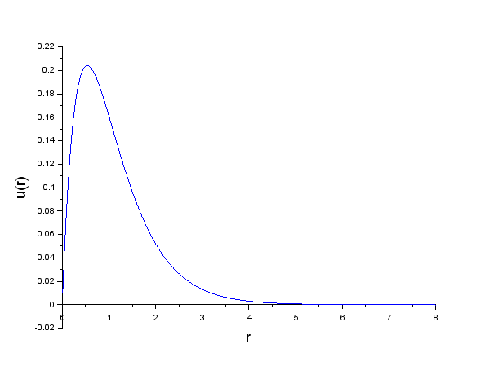

Enter a:5

Enter guess 1 for energy(eV):-9

Enter guess 2 for energy(eV):-12

The energy eigen value (eV) for a=5A is:

-10.92985

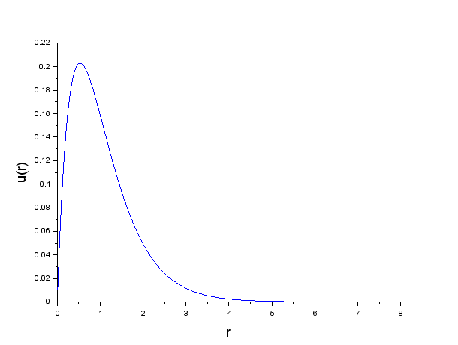

Enter a:7

Enter guess 1 for energy(eV):-10

Enter guess 2 for energy(eV):-12

The energy eigen value (eV) for a=7A is:

-11.649573

